**PRACTICAL NO. 08**

**8. Programs on Basic jQuery**

1. **jQuery Basic, jQuery Events**

**jQuery Basic for if button click Current text changed into different text .**

<!DOCTYPE html>

<html>

<head>

<meta charset="utf-8">

<meta name="viewport" content="width=device-width, initial-scale=1">

<title></title>

<script src="https://code.jquery.com/jquery-3.6.0.min.js"></script>

</head>

<body>

<h1 class="box">Hello World..!</h1>

<button id="btn1">change</button>

<script type="" src="Subline/1st.html"></script>

<script type="" >

$(document).ready ( function(){

$('#btn1').click(function(){

$(".box").text("It's TG");

});

});

</script>

</body>

</html>

**OUTPUT :**

**Text after Button Click**

**Text before Button Click**

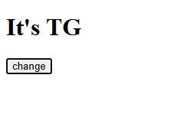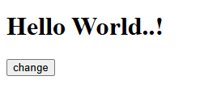

**jQuery Events**

<!DOCTYPE html>

<html>

<head>

<meta charset="utf-8">

<meta name="viewport" content="width=device-width, initial-scale=1">

<title></title>

<link rel="stylesheet" type="text/css" href="style.css">

<script src="https://code.jquery.com/jquery-3.6.0.min.js"></script>

</head>

<body>

<div class="box"></div>

<div class="fadeout"><h1>This is FadeIn and FadeOut</div>

<button id="btn1">FadeOut</button>

<button id="btn2">FadeIn</button>

<script type="" src="Subline/1st.html"></script>

<script type="" >

$(document).ready ( function(){

$('#btn1').click(function(){

$(".box").fadeOut();

});

$('#btn2').dblclick(function(){

$(".box").fadeIn();

});

});

</script>

</body>

</html>

**OUTPUT :**

**Before click() and dblclick() event**

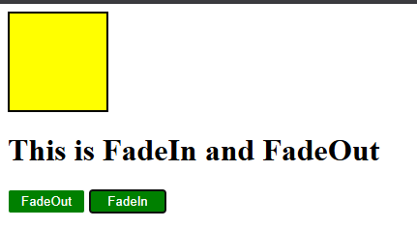

**After click() event**

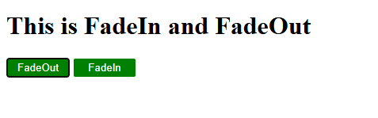

**After dblclick() event**

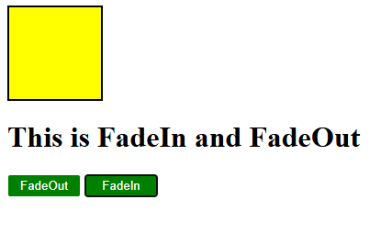

**B. jQuery Sliding effects**

**code:**

<!DOCTYPE html>

<html>

<head>

<meta charset="utf-8">

<meta name="viewport" content="width=device-width, initial-scale=1">

<title></title>

<script src="https://code.jquery.com/jquery-3.6.0.min.js"></script>

<style>

#slideBox {

width: 300px;

height: 150px;

background-color: yellow;

color: white;

text-align: center;

line-height: 150px;

font-size: 20px;

margin: 20px 0;

}

</style>

</head>

<body>

<script src="jquery/jquery.js"></script>

<h2>Slide Box Example</h2>

<div id="slideBox"></div>

<button id="slideUpBtn">Slide Up</button>

<button id="slideDownBtn">Slide Down</button>

<button id="slideToggleBtn">Slide Toggle</button>

<script>

// Slide Up

$("#slideUpBtn").on("click", function(){

$("#slideBox").slideUp(1000); // slides up in 1 second

});

// Slide Down

$("#slideDownBtn").on("click", function(){

$("#slideBox").slideDown(1000); // slides down in 1 second

});

// Slide Toggle

$("#slideToggleBtn").on("click", function(){

$("#slideBox").slideToggle(1000); // toggles slide up/down

});

</script>

</body>

</html>

**OUTPUT :**

1. **SLIDE UP**

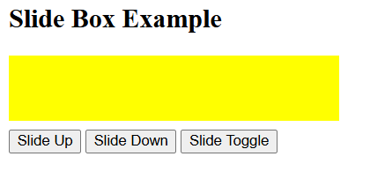

1. **SLIDE DOWN**

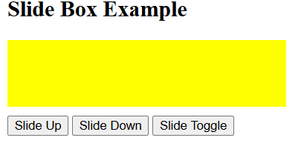

1. **AFTER TOGGLE**

